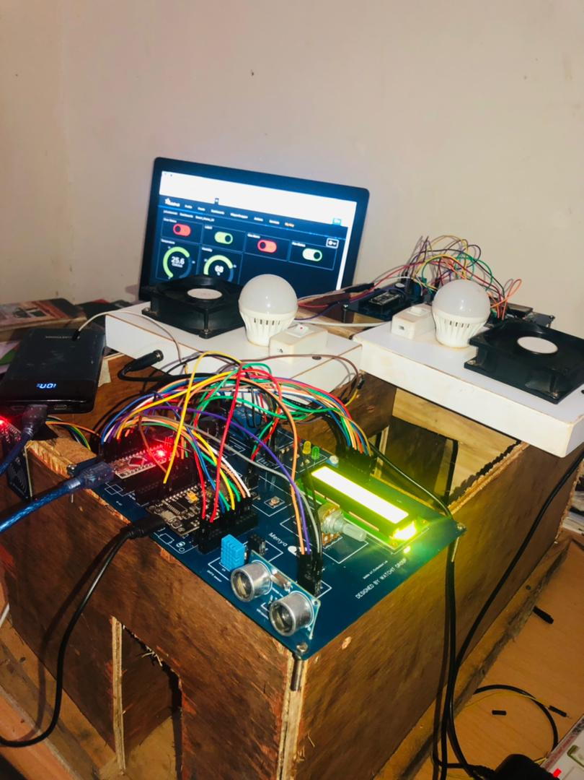

**Smart Home Project Report**

**Submitted To:** Dr. Oliver

**Date:** April 20,2022

**Campus:** Kigali Campus Day

**Group Members:**

1. Faith Makulah Swen-16850/2020
2. Julius Kanneh -17569/2021
3. Timothy Belekollie -17609/2021
4. Jacob Zubah Dukuly Jr-16753/2020
5. Bedell Sandi -17762/2021
6. ABDURAHMANE Sow -17416-2021
7. Amos Thibault BIKARI -16757/2020
8. Bleatoh Karnga -16700-2020
9. Arthur KAYONGA -16725-2020
10. Nishimwe Aline -17536/2021
11. Joyce Dukuze -16484-2020
12. Sandrine Kwizera -15563-2019
13. Latifa Umutesiwase -17448/2021
14. Richmond Jallah -17421-2021
15. 17299/2020 Mutoni Mignone

**1.0 Project Overview/Introduction**

We're living in the Fourth Industrial Revolution where technology has advanced. IoT is one of the important emerging technologies in this era. IoT is the system of interrelated devices connected to a network without interference with ahuman-machine interface.

Almost all of the work we do is done with the help of an automation system or computer-controlled. Now people are moving towards smart systems. As technology is upgrading day by day people want more security in their daily life. We know maintaining the security level for the home is very crucial.

Therefore, we have discussed and implemented the SMART HOME using IoT technology which will help to make homes automated and provide a certain level of security for the homes thus giving house owners remote control access to their home appliances.

This SMART HOME is fully controlled by the members of the family. This home is made by special structure wiring with the use of TCP/IP connection where the users (family members) can access using a simple client-side control. By using this system members can switch on the lights, open the doors, control the temperature of the Air Conditioner/fan, and monitor the kitchen for gas leakage. This SMART HOME enhanced the better living for mankind.

In this project we will be discussing Smart Home, the importance,benefits, advantages,reasons why you need a smart home, how smart home can improve your your life,identifying problems and solutions, functional and nonfunctional requirements, UML diagrams (Unified Modeling Language) and components/devices use in our Smart Home.

**1.2 Problem our proposed solution is solving**

With the help of the Smart Home it will improve the quality of life and convenience in the home. Here are a few solutions of Smart Home:

* Save energy and time
* Prevent Burglary
* Prevent Fire damage
* Prevent water damage
* Detection of bacteria

**1.3 Benefits of Smart Home**

* Smart homes allow you to have greater control of your energy use, all while automating things like adjusting temperature, turning on and off lights, opening and closing window treatments, and adjusting irrigation based on the weather.
* Smart homes provide insights into energy use that can help you become more energy efficient and mindful of ecological factors.
* Smart homes can pinpoint areas where you’re using more energy than you need to, allowing you to cut back on those areas and save money.

**1.4 *Advantages of a Smart Home:***

* *Energy efficient*
* *Enhanced security*
* *Hands- free convenience*
* *Save time with automated tasks*

**1.5 *Reasons Why You Need to Make your Home a Smart Home:***

* *Efficiency: With one touch button or mobile phone application, you can control numerous gadgets or systems. With the help of the smart device, you would be able to operate your heating and cooling as well as turn on and turn off lights with a single click from anywhere in your house.*
* *Convenience: Having a smart home permits you to deal with many electronic gadgets and systems from over the house or over the world. Draw the shades, turn on lights, and monitor security.*
* *Comfort: Smart homes make your life comfortable; you do not have to move all over the house to perform various functions. With smart devices, you can perform all household operations through applications while sitting comfortably on the sofa or in bed.*
* *Peace of Mind: A smart home is also a major way to give peace of mind; you can utilize the smart device to check the doors, windows, water spill sensors etc.*
* *Customization: Smart homes also allow you to have electronic things the way you like to have them. You can have the shades drawn automatically at a certain time, adjust the brightness of indoor as well as outdoor lighting as per your choice.*

**1.6 *ways in which a Smart* Home can improve your life:**

* Save money on energy bills
* Easily secure your home
* Spot a leak sooner
* Automate lights
* Lock and unlock doors
* Stay connected and protect your family

**1.7 System Analysis Design & Methodologies (SSADM)**

**Functional Requirements:**

* Authentication (Swapping of key cards to open /close door)
* Monitor the temperature
* Detect gas leakage
* Turn on/off lights
* Turn on/off fan
* Room selection
* Web server

**NonFunctional Requirements:**

* Security
* Privacy
* Reliability
* Availability

**1.8 Use Case Diagram of Smart Home**

Use Case Diagram is a visual representation of different ways and possible scenarios of using a system. It illustrates how a user will perform actions and interact with a particular system, such as a website or an app.

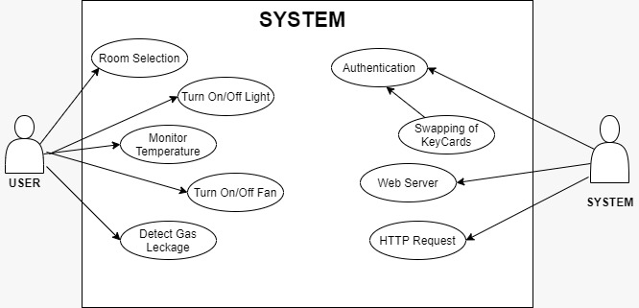

**Authentication(Swapping of Key card)**

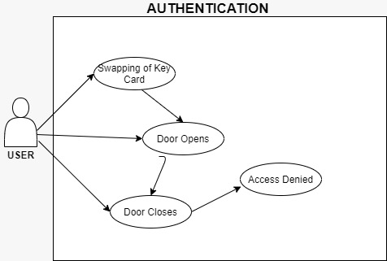

**Room Selection**

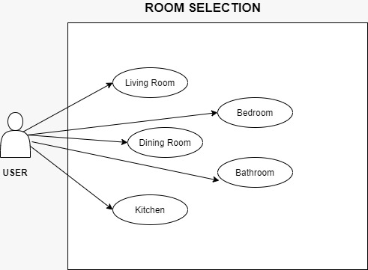

**Monitoring Temperature**

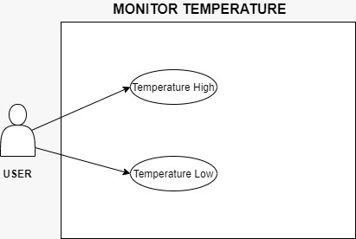

**Detect Gas leakage**

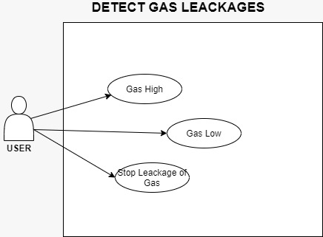

**Turn On/Off Light**

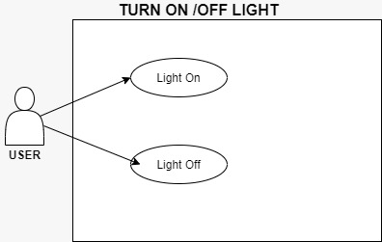

**Turn On/Off Fan**

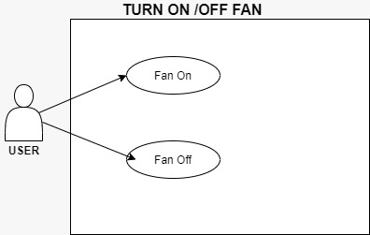

**1.9 Devices /Components that we use in our Smart Home Project :**

| **Components** | **Role in this project** | **image** |
| --- | --- | --- |
| Mq-6 Gas Sensor | It's used to detect leakage of gas in the kitchen. This module has high sensitivity to LPG, iso-butane, propane and LNG. It can also be used to detect the presence of alcohol, cooking fumes, and cigarette smoke. |  |
| NodemCU-ESP8266 Module | It allows us to read sensor values, serves as a client to make http requests to the internet, and a microcontroller to control our appliances. |  |
| Relay | It is used to power on/off the light and fan. With this, DC from the board can be converted to AC power inorder to power-on any AC appliance(in this case, light and fan). |  |
| Servo Motor | It’s used to rotate and push the door. It has the ability to rotate as much as 360 degrees. |  |
| Led | It’s used in our project to prototype the alarm light and the door status. If the LED is on, it means the alarm/door is on/open; otherwise, the alarm/led is off/close. |  |
| Buzzer | It’s used to Simulate the alarms of both the gas sensor and the detection of people around the house when the alarm is activated. |  |
| Wire (male & female) | It’s used to connect all our components used in this project with the NodeMCU board for effective working. |  |
| Arduino Nano board | It is used as the board for detection of people/objects around the house. |  |
| LCD | It’s used to display our the status of the alarm as “Alarm On” or “Alarm Off” |  |
| RFID | We used this as a key swap card to open the door. |  |

**2.** **Software Components Used**

| **Software Component** | **Usage** | **Role in this project** | **Image** |
| --- | --- | --- | --- |
| Arduino Integrated Environment (IDE) | Used for writing Arduino sketches with file extension “.ino” | We used this IDE to develop the sketch which reads data from all of our sensors and control actuators like the LED(Irrigation Pump). The sketch also includes the web server code to interact with the internet to send |  |
| IFTTT |  |  |  |
| ADAFRUIT IO CLOUD |  |  |  |
| GOOGLE ASSISTANCE |  |  |  |

**Images & Screenshots**

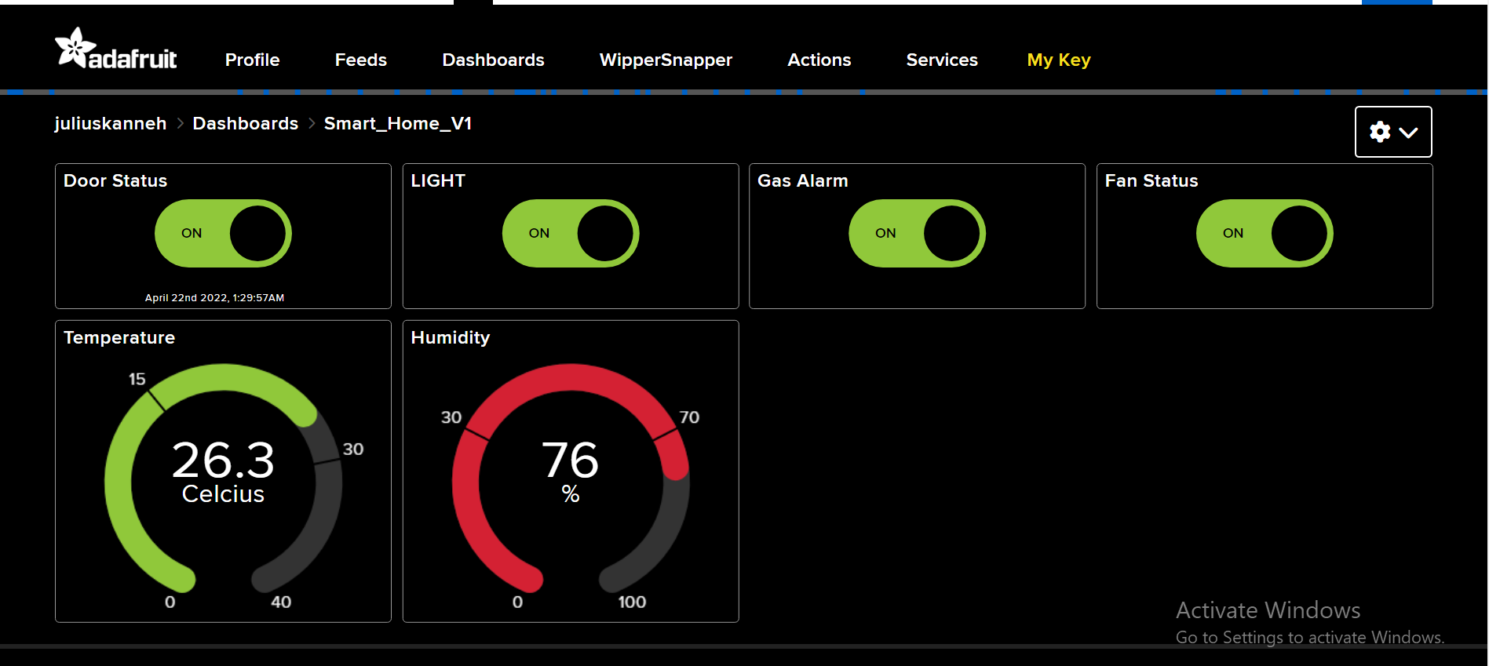

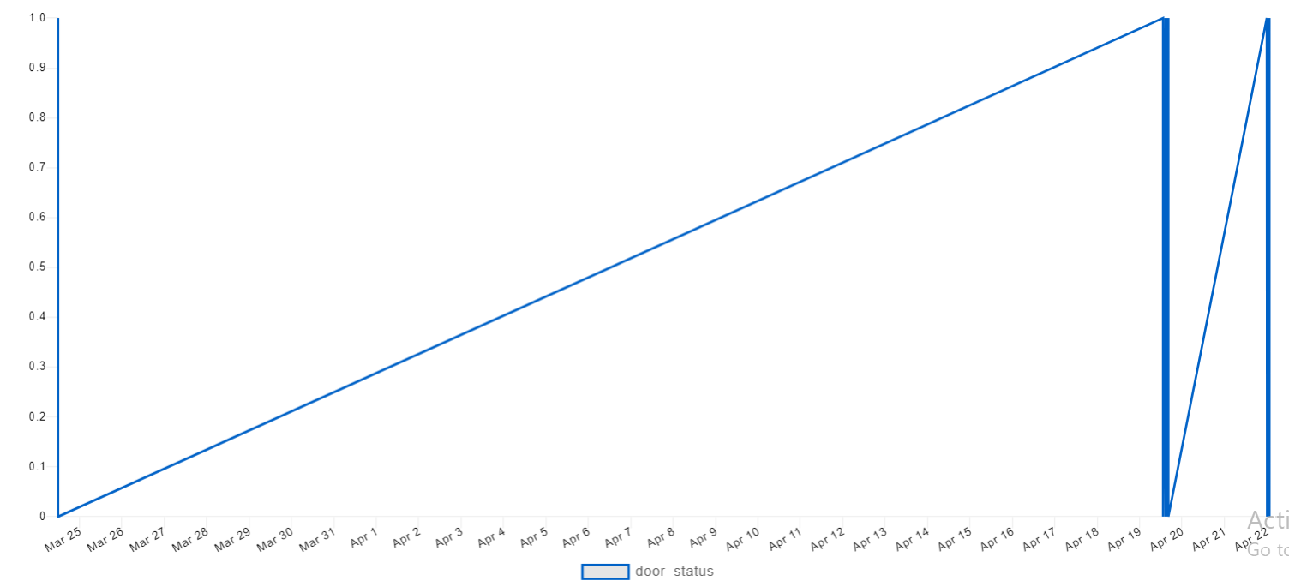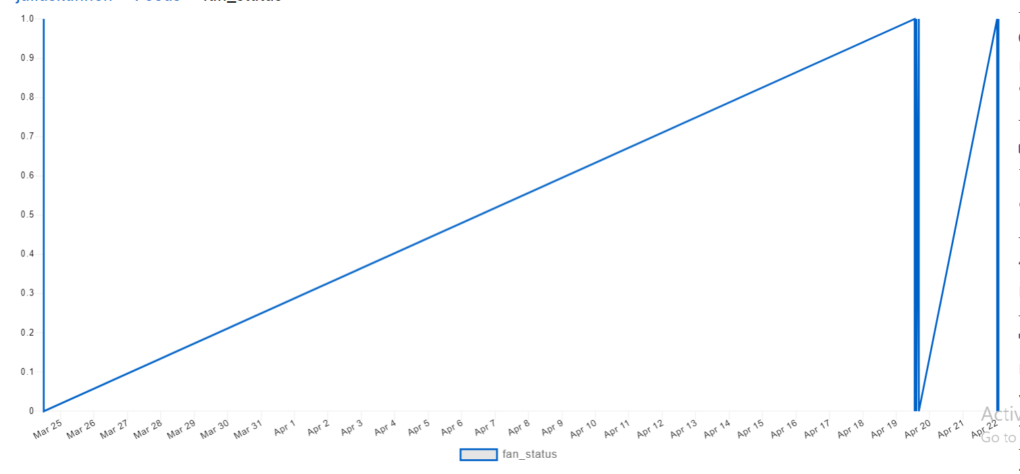

**3.Conclusion**

The main purpose of our smart home system is to provide easy access to controlling appliances, lights, fans, doors and other devices remotely using a smartphone or tablet through an internet connection. It helps to save electricity, time, and money. This system also helps homeowners to protect their homes from burglars, fire damage, water leakage by monitoring their appliances using their smartphones.

So, what are you waiting for to make your home a smart Home.